Swimmer/Diver:

Please watch the videos below prior to lifting. These videos provide very good visual and technique guidelines for several exercises that we will consistently perform during training- especially for beginners. The videos should take approximately 30 minutes to watch.

[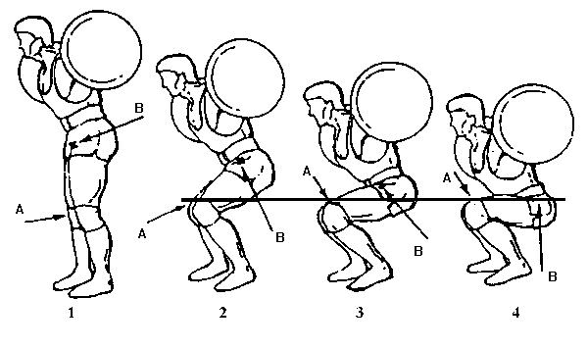](http://www.google.com/url?sa=i&source=images&cd=&cad=rja&docid=9wDiM3JRz6epxM&tbnid=xFkO3G2EThboFM:&ved=0CAgQjRwwAA&url=http%3A%2F%2Fwww.machinemuscle.com%2Fsquats-the-king-of-all-exercises%2F&ei=t85aUc3GCsPD4APNo4DgAw&psig=AFQjCNHCgXMQY1KDi19eb5JSTEjTTvQWlw&ust=1364992055209326)**Squat:**

<http://www.youtube.com/watch?v=xDdSZmWNYQI>

<http://www.youtube.com/watch?v=QKKZ9AGYTi4>

[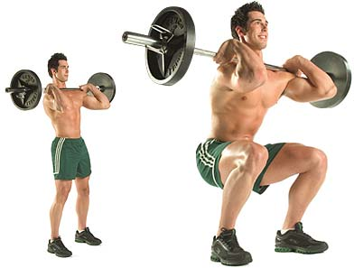](http://www.google.com/url?sa=i&source=images&cd=&cad=rja&docid=3TymJ1iRbptMEM&tbnid=8vKXmnSQEt8CJM:&ved=0CAgQjRwwAA&url=http%3A%2F%2Ffitnessbodygain.com%2Ffront-squats%2F&ei=QM1aUdvnLori4APL14GgBw&psig=AFQjCNFIXMooWc-APEBkX5ax4mam_Srudw&ust=1364991680792172)

**Front Squat:**

<http://www.youtube.com/watch?v=VVNblYv02z0>

[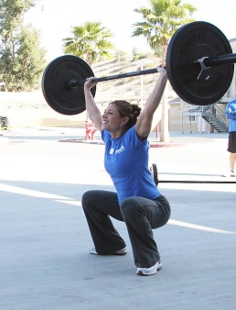](http://www.google.com/url?sa=i&source=images&cd=&cad=rja&docid=yvNaZF9RqChm7M&tbnid=7ZN1hbJ74ZjK9M:&ved=0CAgQjRwwAA&url=http%3A%2F%2Fcrossfitbattlefield.com%2Ftag%2Foverhead-squat%2F&ei=bs9aUfG-MrXA4AOX4ICABw&psig=AFQjCNHojRJwEbmNs9Oikt7zyMMvId34LA&ust=1364992238852016)

**Overhead Squat:**

<http://www.youtube.com/watch?v=yjVM2bwHDEA>

[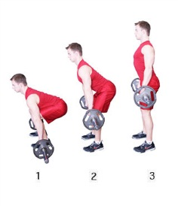](http://www.google.com/url?sa=i&source=images&cd=&cad=rja&docid=Ilqa6hISky84jM&tbnid=OAh2ITqbDDx5jM:&ved=0CAgQjRwwAA&url=http%3A%2F%2Fwww.fullfitness.net%2Fexercises%2Fback%2Fdead-lift&ei=1s9aUYzHCpWl4APzg4HwDg&psig=AFQjCNHh9xyfmWA7HzlmgM1QCedkZLquGQ&ust=1364992342231519)

**Dead Lift:**

<http://www.youtube.com/watch?v=pjBI9qxibTc>

**Push Jerk/Push Press:**

<http://www.youtube.com/watch?feature=endscreen&v=x4eysYloOOk&NR=1>

<http://www.youtube.com/watch?v=gTu8QWrLtUM>

I certify that I have watched the above videos and will ask questions to a coach if I do not understand an exercise. I understand that technique and doing an exercise properly to avoid injury is more important that the amount of weight that I lift.

_____________________________________